**Introduction:**

Machine learning can be used to evaluate real estate market to increase sales and profits. It is less time and resource consuming compared to other evaluation techniques. Machine learning regression for residential real estate evaluation will help improve performance.

**Exploratory Data Analysis:**

There were two data sets provided. The first data set is train, that is used to create the model and the second data set is to test the model and predict the survival of passengers. The train data has 1460 rows of data and 81 variables. The data is a combination of categorical variables that describe the features of the house. The response variable is SalePrice.

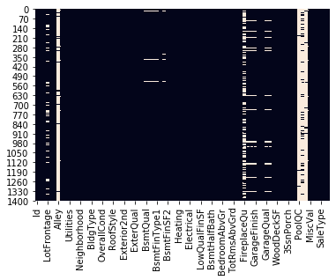**Data Preparation and Overview of Programming:**

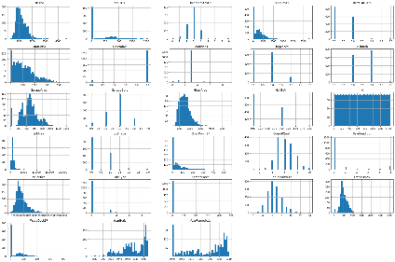The first step to get the data ready to create the model, is to figure out the missing values and to drop or fill the values based on the percentage missing. The next step was to drop the columns that the response variable is not strongly dependent on. There are 27 columns left that influence the response variable. I converted the string values in columns manually to numeric values, which is the same as LabelEncoder. The histograms below are the distribution plots of the variables.

**Programming:**

The four regression models used for this analysis are Linear, Ridge, Lasso and ElasticNet. The python packages used for data handling are Pandas, Number, SciKitLearn. The variable ‘SalePrice’ was removed to create a subset of variables and response variable. For every regression model the model score and root mean squared error metric for performance evaluation 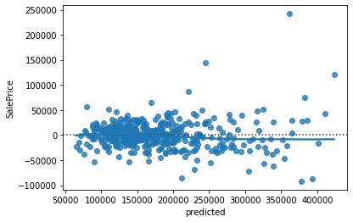was calculated.

**Lasso**

**Ridge**

**Linear** 

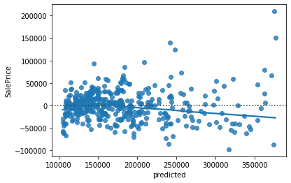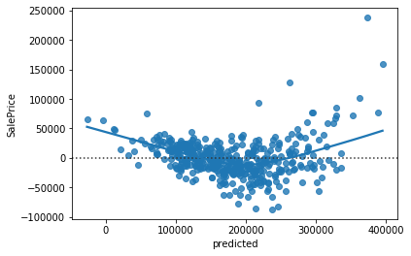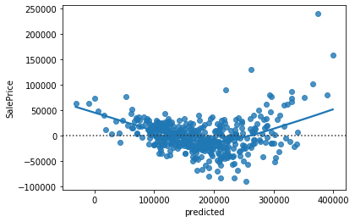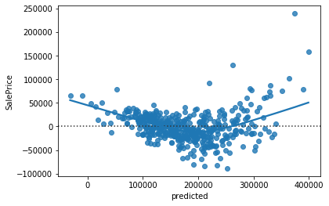

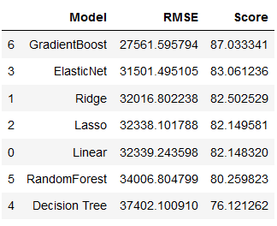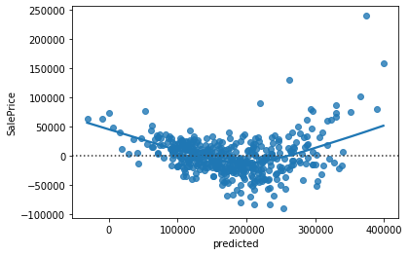Random Forest and Gradient Boosting modeling methods were also implemented on the train and test datasets to predict the response variable.

**GradientBoosting**

**RandomForest**

**ElasticNet**

**Insights & Conclusions:**

Based on the performance of the models with respect to the root mean squared error metric, I recommend that the Gradient Boosting model be used to predict the home values. The variables that influence the price of the home are OverallQual, YearBuilt, TotRmsAbvGrd, FirePlaces, GrarageCars, GarageArea, YearRemodAdd.

**Root mean squared Error Metric and Model Score**

**Appendix:**

The ipynb notebook and an html version of the notebook along with the output and Kaggle submission scores are included in the submission.